20.47: a)
and so 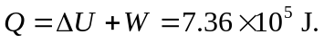
b) Similarly,
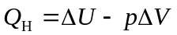
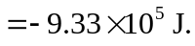

c) The work done during the adiabatic processes must be found indirectly (the coolant is not ideal, and is not always a gas). For the entire cycle, 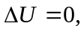 and so the net work done by the coolant is the sum of the results of parts (a) and (b), 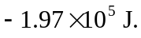The work done by the motor is the negative of this, 